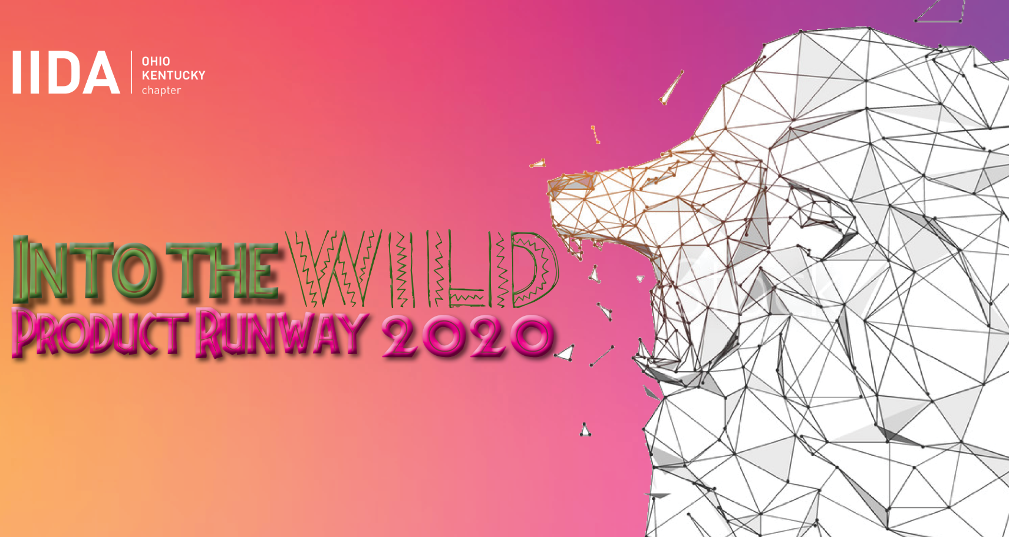
DESIGN CHALLENGE
The theme for Product Runway 2021 is Into the Wild. Each team has randomly selected an animal habitat & has been instructed to select one animal that would reside within that specific environment. The teams were tasked to construct several high fashion accessories using materials provided by their industry partners, to showcase the chosen animal. Teams are composed of 4-5 members
The judging criteria will be focused on recognition of the animal, use of material, craftsmanship, & showmanship during the runway show. The design challenge will also focus on the percentage of recycled/repurposed material. Each team will need to address their usage of recycled/repurposed materials with the judges prior to the runway show. Teams are encouraged to show samples of materials to help illustrate how items were used in construction.
JUDGING CRITERIA & SCORING
Conceptual Interpretation (Total of 55 points):
Representative of the Animal affiliated with assigned domain (25 points) – Each team is provided a domain & can select an animal that would reside within that domain. Contestants will be judged based on how well they have represented the chosen animal.
Use of Recycled/Repurposed Materials (20 points) – Teams must showcase recycled material gathered materials deemed “trash” in resource libraries & discontinued manufacturer remnants, etc. Teams are encouraged to provide a listing of materials used in the creation of the accessories, calling out all sustainable products. Additionally, teams need to be prepared to discuss the sustainable story of the manufacturer partner during the pre-judging. Any questions on material usage can be addressed with PR committee chairs.
Dramatic Design and Styling will be awarded (10 points) –Each accessory should be dramatic, while contributing to the overall look & coordinating with the other team members' accessories.
Craftsmanship (Total of 25 points):
Garment Construction (15 points) – Attention will be paid to the overall construction of the garment. Points will be awarded based on innovation and design.
Material Usage (10 points) – Special consideration & points will be awarded based on the difficulty of the type of material you are using to construct the items. Higher points will be awarded for innovative use of materials normally not used to construct or fabricate clothing & accessories.
Runway (Total of 20 points):
Showmanship (20 points) –Points will be awarded based on how well your model performs on the catwalk.

SPECIAL NOTE: ABSOLUTELY NO ANIMALS ALLOWED IN RUNWAY SHOW!

